

**Installation Guide**

Table of Contents

**Installing SQL Server** 4

1. Select new SQL Server Installation 4

2. Choose Developer Edition 4

3. Agree to the License Terms 5

4. Check for Microsoft Updates 5

5. Install Rules 6

6. Install Rules 7

7. Instance Configuration 8

8. PolyBase Configuration 8

9. Java Install Location 9

10. Server Configuration 9

11. Database Engine Configuration 10

12. Analysis Services Configuration 11

13. Integration Services Scale Out Configuration – Master Node 11

14. Distributed Replay Controller 13

15. Distributed Replay Client 13

16. Consent to install Microsoft R Open 14

17. Consent to install Python 14

18. Offline Installation 15

19. Ready to Install 16

20. Installation Finished 16

**Microsoft SQL Server Management Studio Installation** 17

1. Welcome Screen 17

2. SSMS Connections 17

3. Database Restore 18

4. Change Path 19

5. Computer Management 19

6. Extract R22 zip file 20

7. Post File(s) Extraction 21

8. Setting Environment Variables 22

9. Edit Path to Add Temenos and Java 23

10. System Properties 24

11. Restart Machine 24

12. Navigate and Locate 24

13. Verifications 25

14. Verify setting according to Config 26

15. Verify TAFJ Locking Mechanism 26

16. Choose MSQL according to Config 27

**For Classic Mod** 27

1. Open TeraTerm Applications 27

2. Enter Local User Credentials 28

3. Run Command 28

4. Successful configuration of T24 Classic Mode 29

5. Login Credentials 29

6. Successful Login 29

7. Add new DB Tool User 30

8. Verify User 30

9. Successful Login 31

10. T24 UXPBrowser 31

11. Check Configurations 32

12. Verifications 32

13. Run R21 Transact File 33

14. T24 Legacy Browser 33

15. Map the Address 34

# **Installing SQL Server**

To begin with the Temenos installation process, first the database will have to be installed for which the following steps need to be performed:

## Select new SQL Server Installation

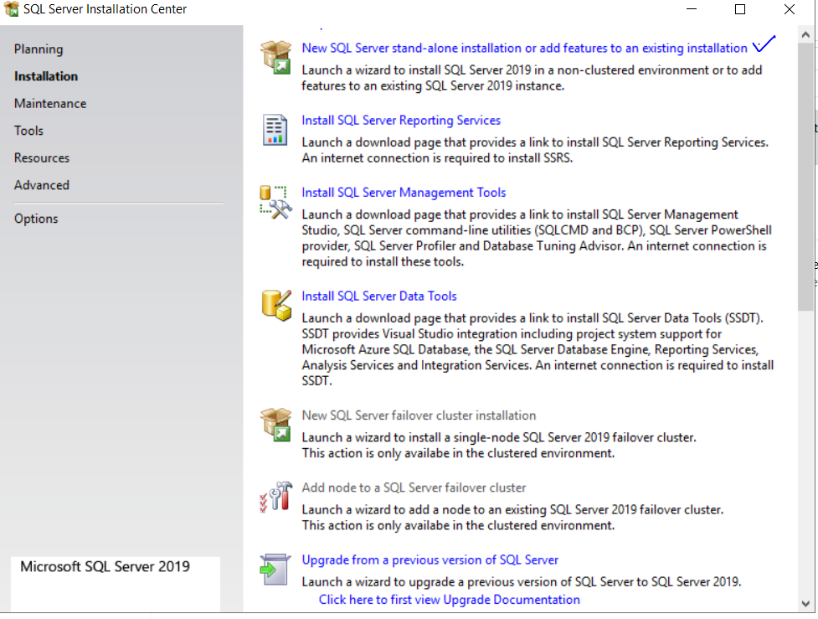

## Choose Developer Edition

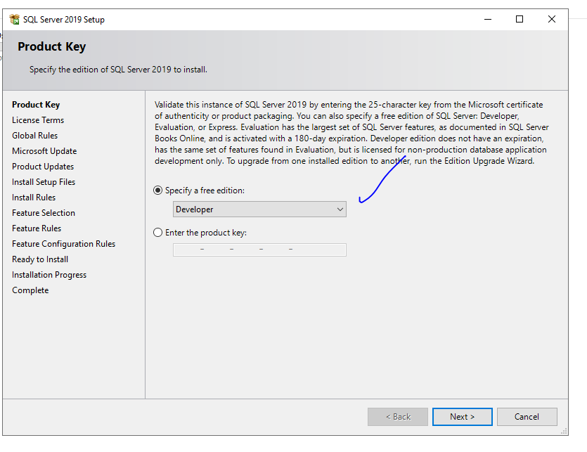

## Agree to the License Terms

## Check for Microsoft Updates

## Install Rules

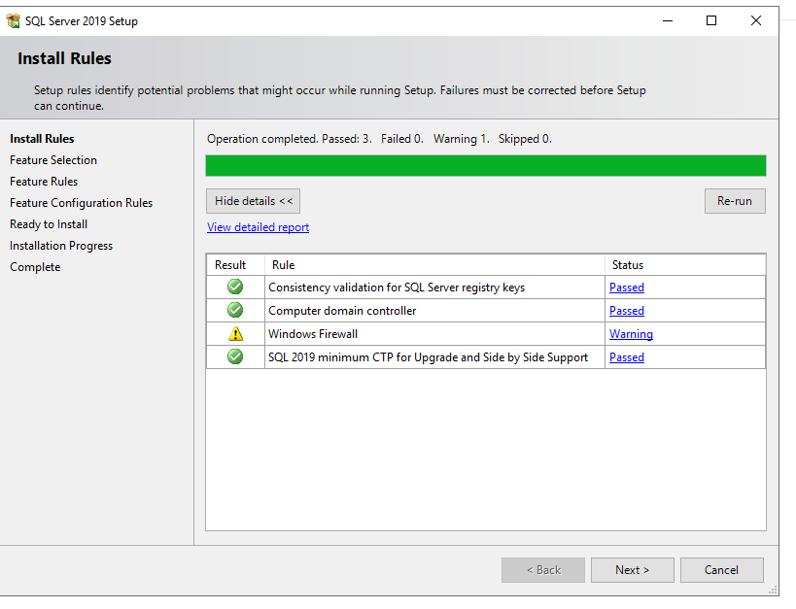

## Install Rules

For installing rules, the user will have to:

* Press **Select All** for the Instance Features as highlighted below in the picture
* Change directories of the following to D drive:
  + Instance Root Directory
  + Shared Feature Directory
  + Shared Feature Directory (x86)

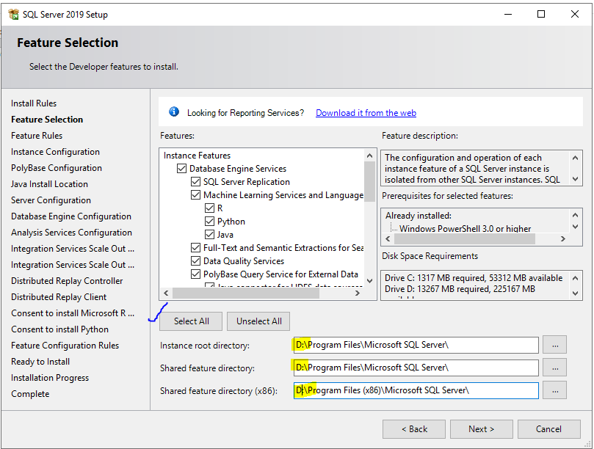

## Instance Configuration

Choose **Default Instance** and procced to the next step.

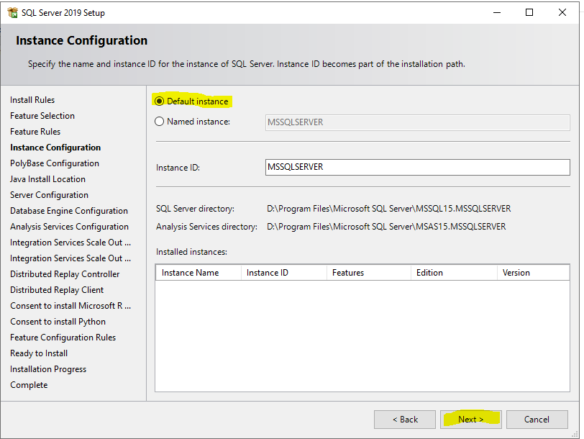

## PolyBase Configuration

Choose “**SQL Server as standalone PolyBase-enabled instance**” and proceed forward.

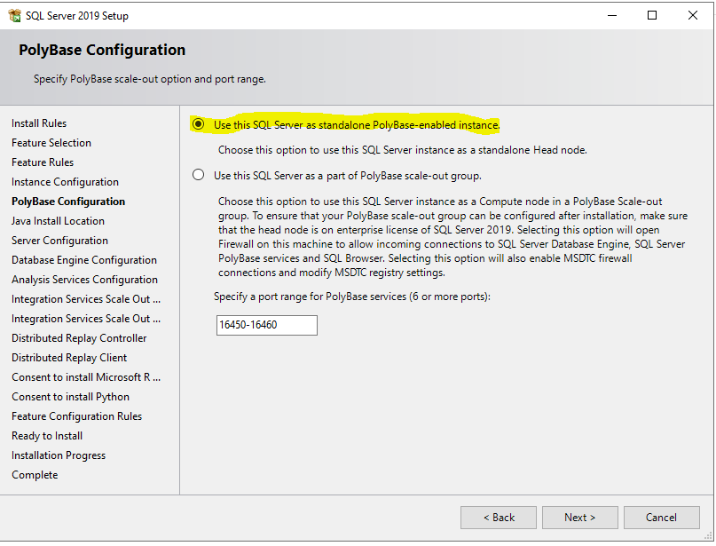

## Java Install Location

Choose the option “**Install Open JRE 11.0.3 included with this installation**” and proceed forward.

## Server Configuration

## Database Engine Configuration

* First step would be to select the “**Windows Authentication Mode**”
* Once that has been selected, the user will go to the option “**Add Current User**” where they will have to add a new user

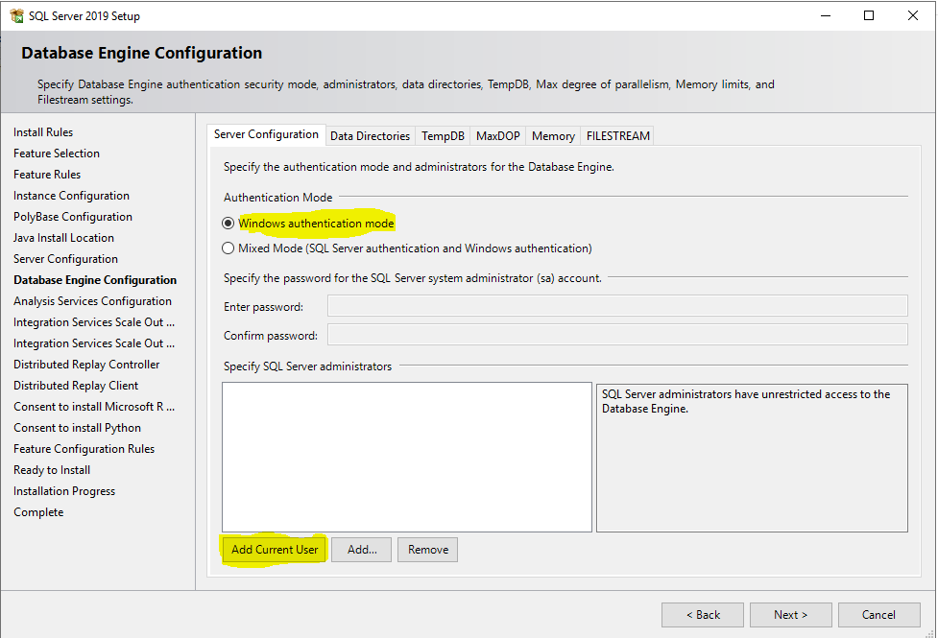

1

2

* Once the user has been added, the next step would be to choose the option “**Mixed Mode (SQL Server Authentication and Windows Authentication)**”
* **Enter password and confirm password** in the fields provided
* Click on “**Add**” to proceed forward. Once done press on “**Next**”

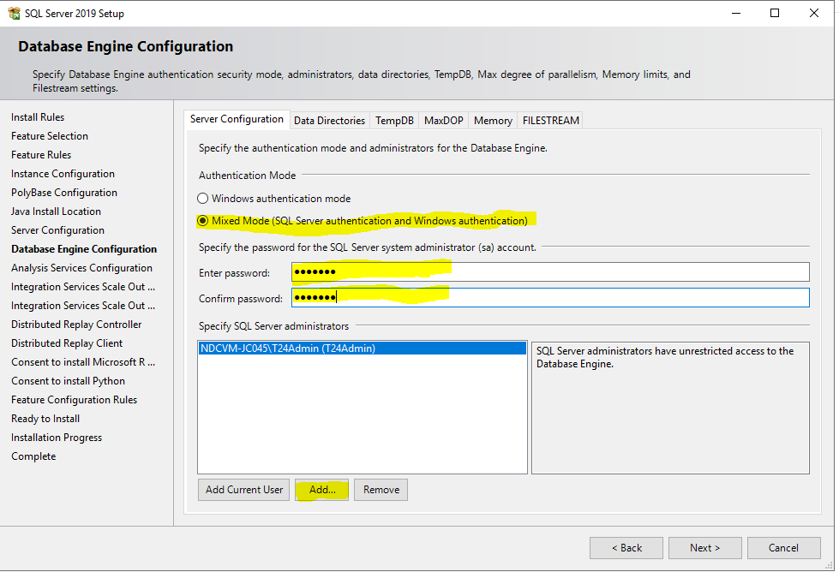

3

2

1

## Analysis Services Configuration

Choose “**Tabular Mode**” and then press on “**Add Current User**”

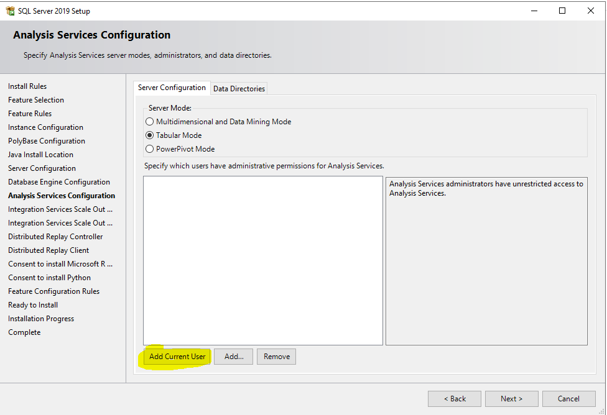

## Integration Services Scale Out Configuration – Master Node

* Choose “**Create a new SSL Certificate**” and then proceed to “**Next**”

* Continue clicking on “**Next**”

## Distributed Replay Controller

Click on “**Add Current User**” and proceed forward.

## Distributed Replay Client

Click on “**Next**” and proceed forward.

## Consent to install Microsoft R Open

Click on “**Accept**” to proceed with the downloading.

## Consent to install Python

Click on “**Accept**” to proceed with the downloading.

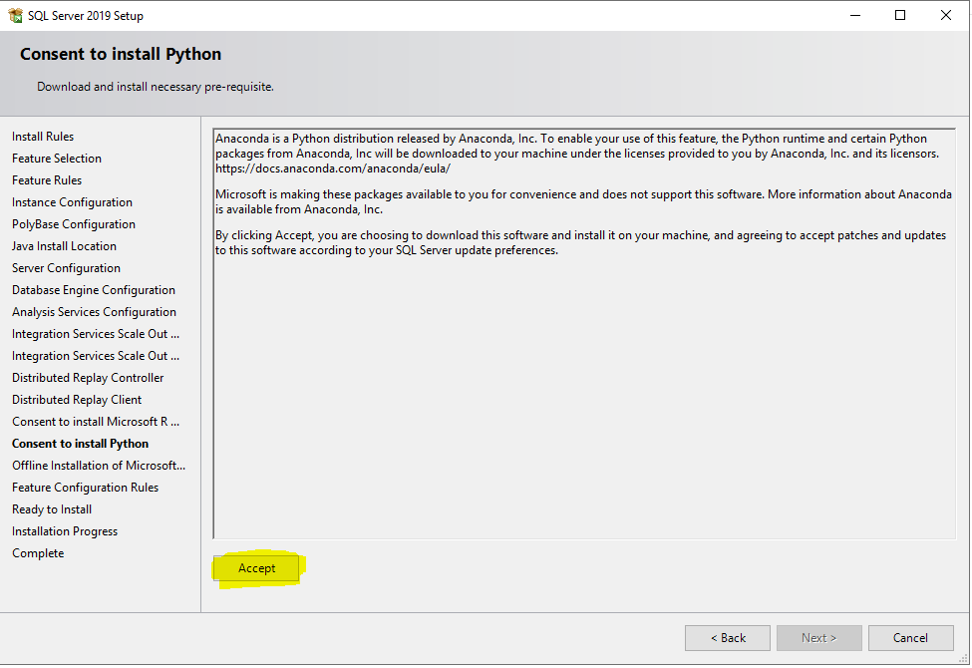

## Offline Installation

Click on the links to start the automatic download of relevant files.

Once all links have been accessed. Create a folder in D drive, move the downloaded files in the folder and provide the path of the folder in the “**Install Path**” field. Then press “**Next**” and move forward.

## Ready to Install

Click on “**Install**” to complete the process.

## Installation Finished

Click on “**Close**” to finish the SQL Server installation process.

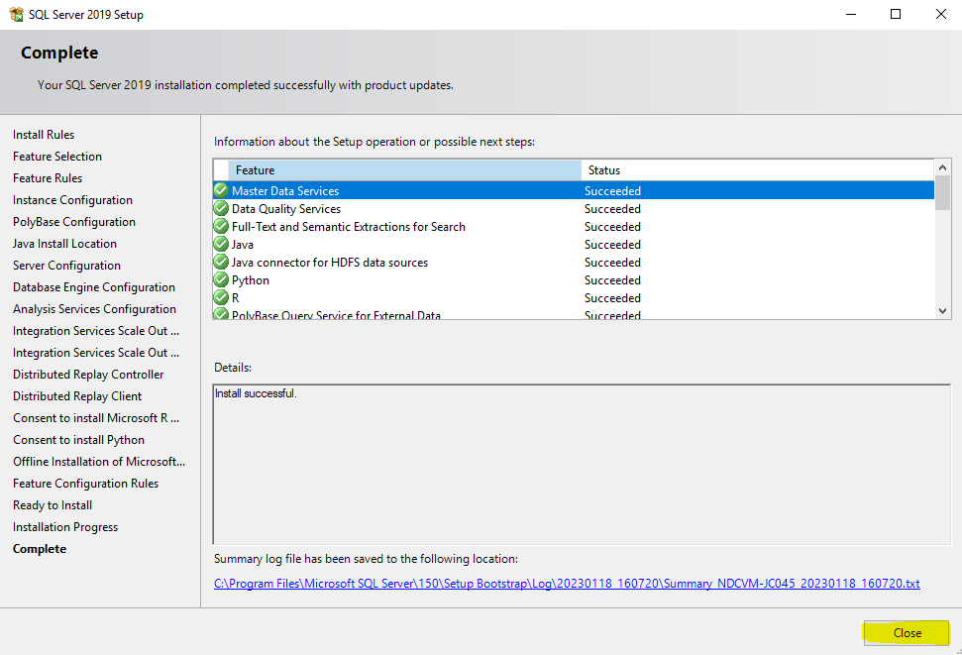

# **Microsoft SQL Server Management Studio Installation**

The next phase in the process is; installing the Microsoft SSMS. The steps will be as follows:

## Welcome Screen

Change the location to the D drive where you want the software and its associated files to be installed.

## SSMS Connections

Enter the login credentials that were previously created in the Database Engine Configuration (Step 11) of the SQL Server installation. Once the credentials have been, press “**Connect**” to proceed forward.

## Database Restore

There is a backup file that is provided by Temenos which has to be restored in this SQL Server. For the restoration, the following step has to be performed.

In the next screen, enter the path of the location where the backup files are present.

## Change Path

## Computer Management

Now a new user for country specific will have to be created.

Now once you’ve created a new user. Stop the SQL server and restart the machine. After restarting; login with the credentials of the newly created user.

## Extract R22 zip file

Now extract R22 zip file except the Database folder since we created the folder by restoring .Bak file(s)

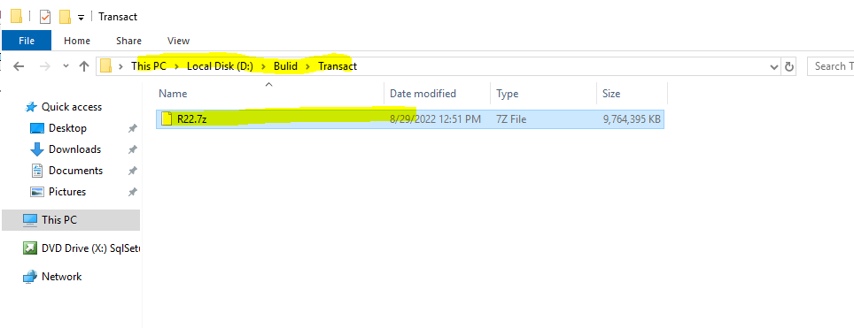

## Post File(s) Extraction

Once all the files have been extracted the **Temenos folder** would contain the following files:

## Setting Environment Variables

The following new values need to be added for each variable:

* BRP_HOME: %TEMENOS_HOME%
* JAVA_HOME: D:\Temenos\3rdParty\JAVA
* JBOSS_HOME: D:\Temenos\R22\AS\jboss-eap-7.3\jboss-eap-7.3
* T24_HOME: D:\Temenos\R22\bnk\UD
* TAFJ_HOME: D:\Temenos\R22\TAFJ
* TEMENOS_HOME: D:\Temenos
* UXPBROWSER: D:\Temenos\R22\UXPBrowser

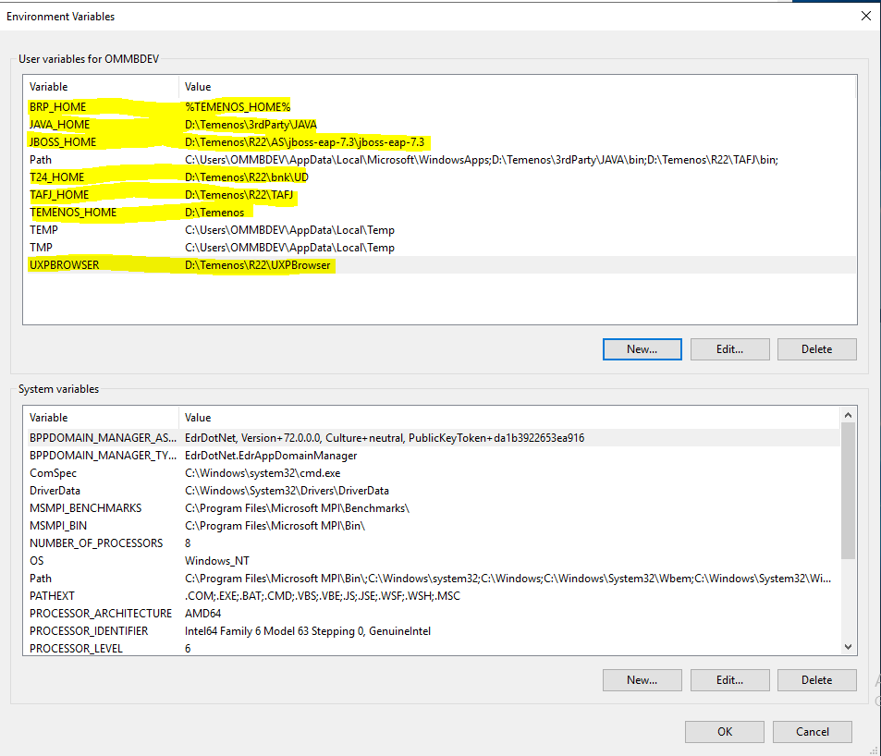

## Edit Path to Add Temenos and Java

Edit the **PATH** variables to add **executable paths for JAVA and TAFJ**

4

3

2

1

## System Properties

Once all of this is done, Press Ok to finish the process.

## Restart Machine

After setting the variable:

* Stop the SQL Services
* Then restart your machine

## Navigate and Locate

Navigate to **D:\Temenos\R22\TAFJ\conf** and Locate ‘**tafj.properties**’ file

## Verifications

Verify highlighted paths in the ‘**tafj.properties**’ file.

After checking the path now verify the following points of the **Database**

• Server IP

• Database name

• Integrated Security =false

• DB user name & DB user password (set according to data base configurations as done previously)

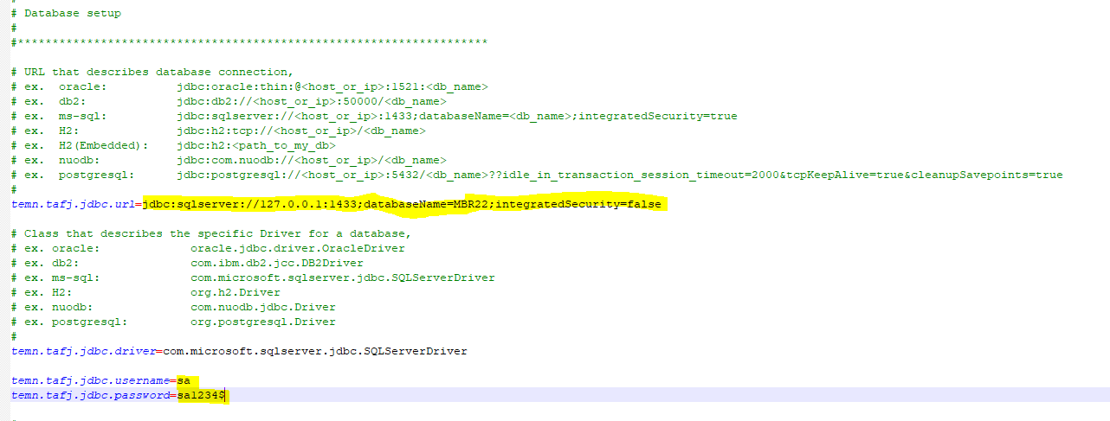

## Verify setting according to Config

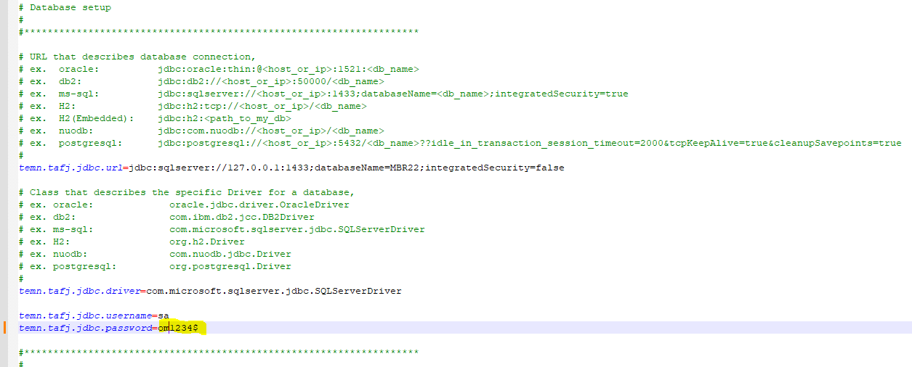

## Verify TAFJ Locking Mechanism

Verify highlighted parts.

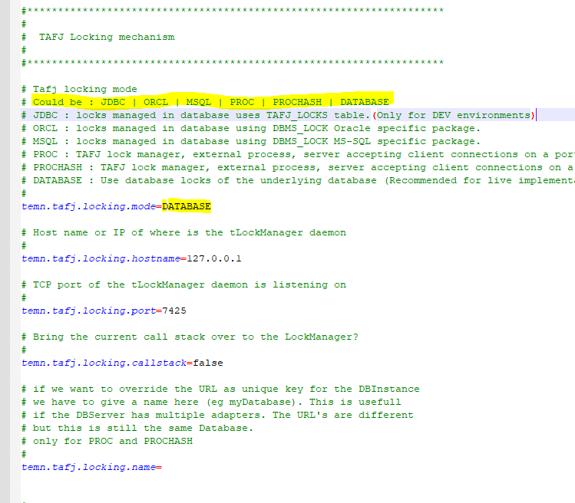

## Choose MSQL according to Config

Choose MSQL According to my Config or you can also choose above mention DBS and then save the file

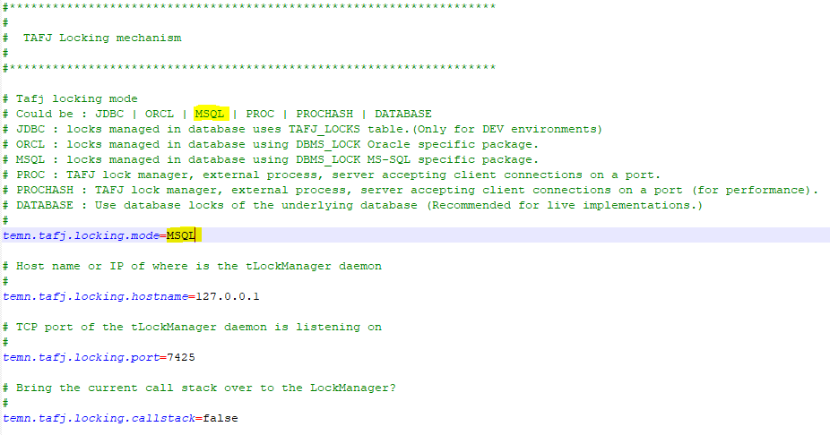

# **For Classic Mod**

The next phase in the process is; as follows:

## Open TeraTerm Applications

Open the tTermPro Application and Connect with **SSH into local host**

## Enter Local User Credentials

## Run Command

Run command **‘tRun EX’** to login to open Classic mod

## Successful configuration of T24 Classic Mode

After running the above command – the following successful Configuration of T24 Classic mode screen will be visible:

## Login Credentials

Please login using the following credentials:

**User**: INPUTT/AUTHOR

**Password**: 123456

## Successful Login

After successfully logging in – the following success screen will be visible:

## Add new DB Tool User

To Add new DBTool user run command on terminal

**‘tUserMgnt –add -u-<UserName> -p <Password>’**

## Verify User

Verify User has been created by logging into DB Tools with Command

**‘DBTools -u <user> -p <Password>’**

## Successful Login

Screen shown after successful login

## T24 UXPBrowser

For T24 UXPBrowser /legacy browser, ensure that ‘**deployments**’ folder is present inside of **Temenos > R22 > AS > jboss-eap-7.3 > standalone**

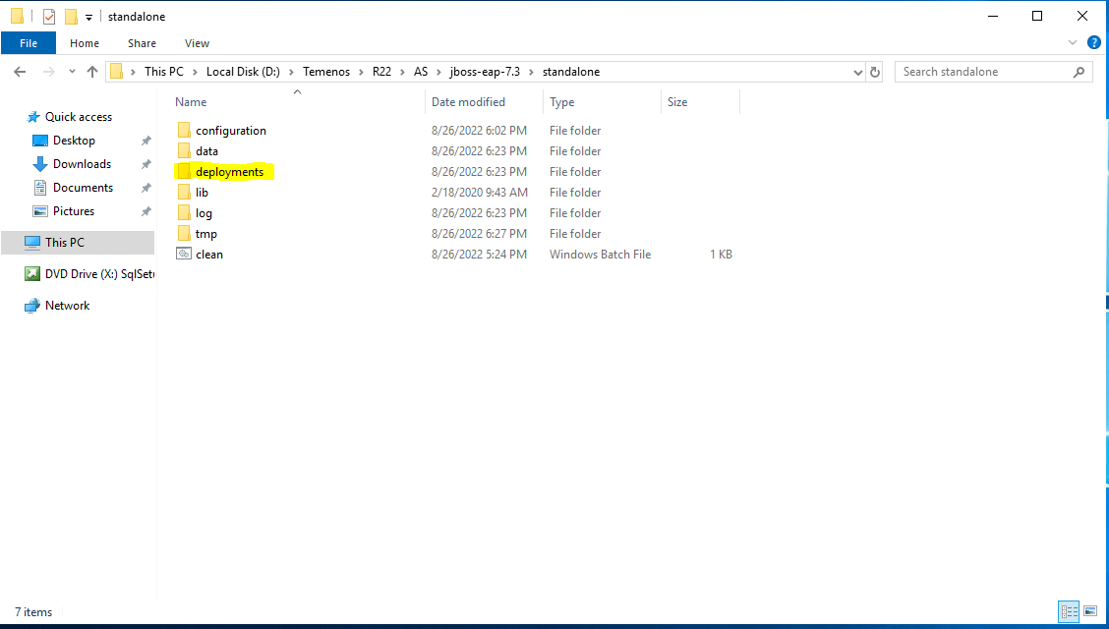

## Check Configurations

Open **‘Transact.xml file’** in **Temenos > R22 > AS > jboss-eap-7.3 > standalone > configuration** with any text editor e.g., Notepad++

Check that all connection strings, database drivers, database credentials are correctly configured.

One such instance is highlighted in the screenshot below:

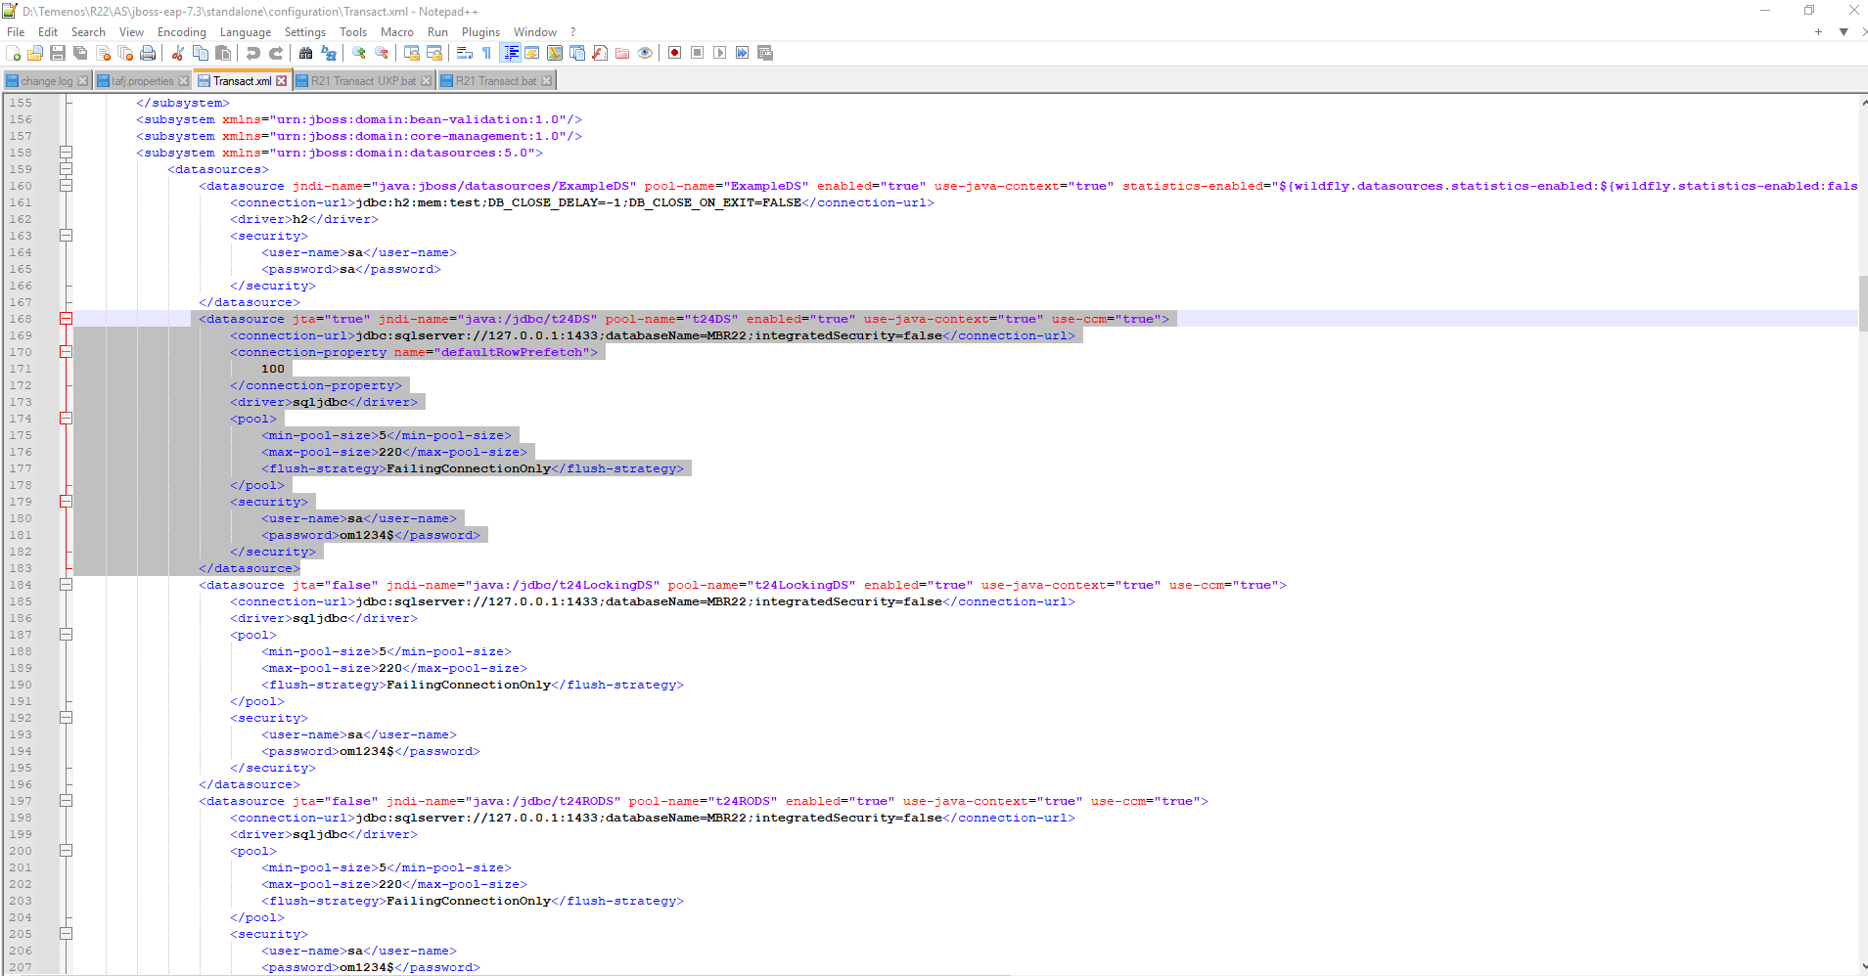

## Verifications

Navigate to **Temenos > R22**, locate the **“R21 Transact UXP” & “R21 Transact”** files

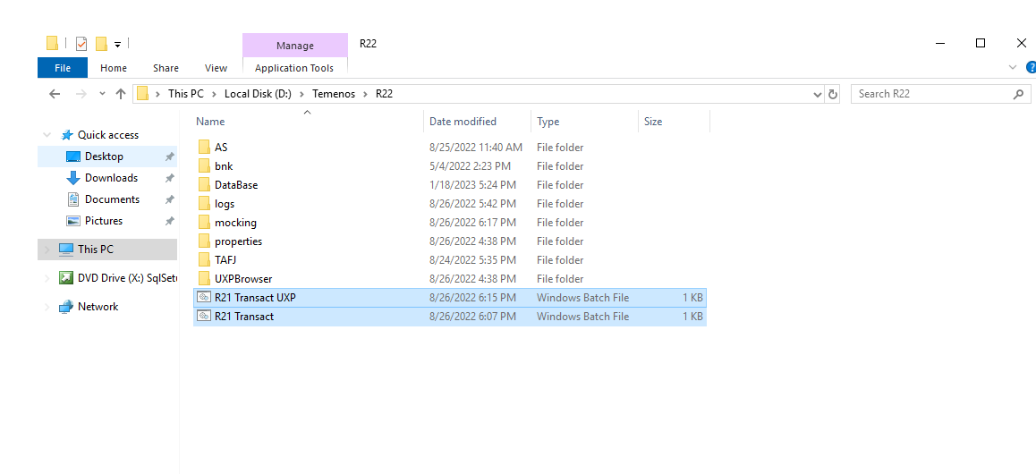

Verify that the highlighted Paths in either file are correct:

## Run R21 Transact File

After verification, run **‘R21 Transact’** file

After running the file - after some time write the URL in your browser

**‘localhost:9089’** this indicates that the server is running (JBOSS)

## T24 Legacy Browser

Then paste this URL **‘http://localhost:9089/R22’** in browser to access T24 Legacy browser which looks like this:

## Map the Address

Map the address **‘http://localhost:9089’** to a port to expose the application to the internet and you should be able to access the application from anywhere

